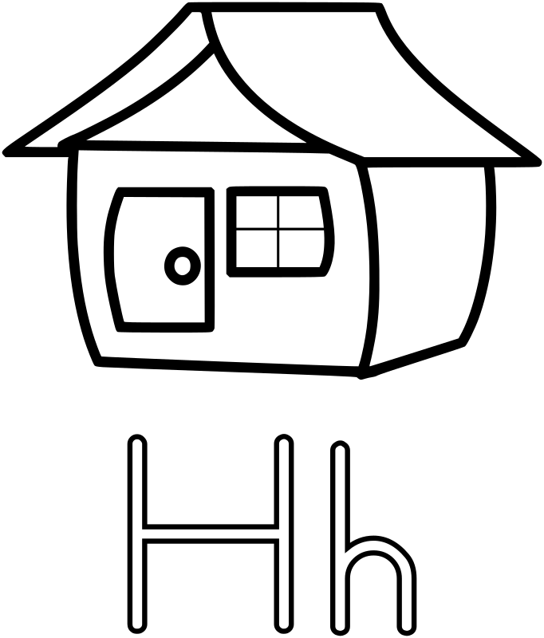

**H/h**

Naam:

Kleur de letter H/h 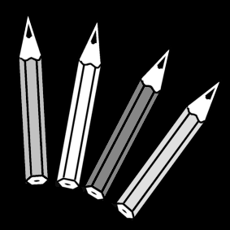



omcirkel de letter H 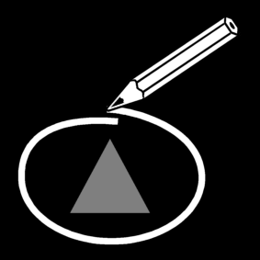

J N L H A T

T H P K S A

Z P R T H U A

B H G F P Y W

V P C H T O N D T E P N H E L

T D Z H D P T O

U A K J H L K P H U K A K S A E H T O U A

B H G A P N T

omcirkel de letter H/h 

het huis staat op de berg.

de rat zit in de hut.

de mol zit in een hol.

hij heeft de hik.

ik hak het hout.

hij zit in de hei.

hans zit in de hut.

wij eten ham.

zet een kruis in het juiste hokje 

|  |  |  |
| --- | --- | --- |
|  |  |  |

|  |  |  |
| --- | --- | --- |
|  |  |  |

hak ham

|  |  |  |
| --- | --- | --- |
|  |  |  |

|  |  |  |
| --- | --- | --- |
|  |  |  |

hek hei

|  |  |  |
| --- | --- | --- |
|  |  |  |

|  |  |  |
| --- | --- | --- |
|  |  |  |

hut hok

|  |  |  |
| --- | --- | --- |
|  |  |  |

|  |  |  |
| --- | --- | --- |
|  |  |  |

hik mol hol

|  |  |  |
| --- | --- | --- |
|  |  |  |

had mol hef

|  |  |  |
| --- | --- | --- |
|  |  |  |

|  |  |  |
| --- | --- | --- |
|  |  |  |

mol hof

|  |  |  |
| --- | --- | --- |
|  |  |  |

hem

haat

|  |  |  |  |
| --- | --- | --- | --- |
|  |  |  |  |

haak

|  |  |  |  |
| --- | --- | --- | --- |
|  |  |  |  |

|  |  |  |  |
| --- | --- | --- | --- |
|  |  |  |  |

hand

|  |  |  |  |
| --- | --- | --- | --- |
|  |  |  |  |

huis

huil

|  |  |  |  |
| --- | --- | --- | --- |
|  |  |  |  |

waar hoor je de H/h? kleur het juiste bolletje  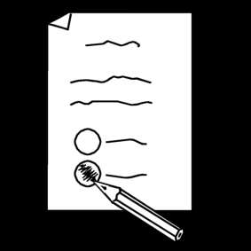

|  |  |  |
| --- | --- | --- |
| fence-800px | johnny-automatic-whole-ham-300px | 15-300px |
|  |  |  |
| **letter-H-800px** | Crying-Smiley-Face-300px | Beschrijving: hut |
|  |  |  |
| shelter-300px | nicubunu-Comic-characters-Lifting-300px | escarpin-300px |
|  |  |  |

duid de H/h aan  

hak ham

hek hei

hok hol

hut hef

hel hem

hik hof

hij hip

his huis

huil had

hen haar

haaf haag

hal hot

hand hars

haal haat

half helm

halm hey

stempel de woorden met de h 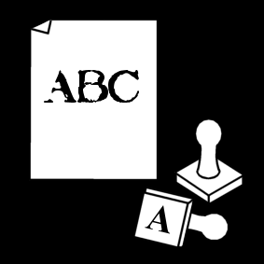

|  |  |  |
| --- | --- | --- |
| **letter-H-800px** | **huis** |  |
| Crying-Smiley-Face-300px | **huil** |  |
| johnny-automatic-whole-ham-300px | **ham** |  |
| Prismatic-Low-Poly-Deer-300px | **hert** |  |
| 1410828205-300px | **hart** |  |
| brownandgreengloves-300px | **handschoenen** |  |
| Top-hat-Black-300px | **hoed** |  |
| Honey-Jar-1-300px | **honing** |  |
| z-pa005-dog-300px | **hond** |  |
| hand-20-300px | **hand** |  |
| freehammer-300px (1) | **hamer** |  |

Bron afbeeldingen:

<https://openclipart.org>

<https://www.pictoselector.eu/>